

|  |  |
| --- | --- |
| **Course Number** | COE 768 |
| **Course Title** | Computer Networks |
| **Semester/Year** | F2020 |
| **Lab No** | 05 |
| **Instructor Name** | Bobby Ma |
| **Section No** | 05 |

|  |  |
| --- | --- |
| **Submission Date** | 10/29/2020 |
| **Due Date** | 10/29/2020 |

|  |  |  |
| --- | --- | --- |
| **Name** | **Student ID** | **Signature\*** |
| Vatsal Shreekant | 500771363 |  |
| Dimple Gamnani |  |  |

*\*By signing above, you attest that you have contributed to this submission and confirm that all work you have contributed to this submission is your own work. Any suspicion of copying or plagiarism in this work will result in an investigation of Academic Misconduct and may result in a “0” on the work, an “F” in the course, or possibly more severe penalties, as well as a Disciplinary Notice on your academic record under the Student Code of Academic Conduct, which can be found online at:*

*www.ryerson.ca/senate/current/pol60.pdf*

**Introduction**

UDP is a transport protocol commonly used by network applications. Unlike TCP, applications based on UDP can send data without the establishment of transport-layer connection.

The socket system call indicates that the transport service is UDP (SOCK\_DGRAM). It does not need to call *accept* for it does not need to deal with connection request. UDP server calls *recvfrom* to wait for data from the client.

*Recvfrom is* same as read with the exception that recvfrom also returns the address of the sender (the client) stored in the argument *fsin*. When the server needs to send data back to the client, it will call *sendto*.

The UDP client makes essentially the same system calls as TCP client to prepare the sock. However, in this case, connect does not trigger a TCP connection. Instead, it associates the socket to the destination address (stored in the argument sin). Because of this association, the client does not need to use *sendto* when it sends data to the server; instead it can use write.

**Procedure**

1. Load time\_server.c and time\_client.c example project and complete the instructions in the lab manual.
2. Modify the ‘time\_client.c’ file to allow the user download multiple files. Consequently, the client program should provide a user interface such that the user can select to download file or quit the program.
3. The PDU should be defined as a PDU structure and the data should be sent in the Final PDU. To predetermine the file size, the *lstate* system call can be used.
4. The following figures implement the time\_client.c and time\_server.c files.

Machine generated alternative text:
C:\Users\Owner\OneDrive - Ryerson University\4th Year\COE 718\Labs_new\Lab3\Demo_768.c
Page 1
1   
/* time_client.c - main */
2   
3   
#include
<sys/types.h>
4   
5   
#include
<unistd.h>
6   
#include
<stdlib.h>
7   
#include
<string.h>
8   
#include
<strings.h>
9   
#include
<stdio.h>
10   
#include
<sys/socket.h>
11   
#include
<netinet/in.h>
12   
#include
<arpa/inet.h>
13   
14   
#include
<netdb.h>
15   
#include
<math.h>
16   
17   
#include
<sys/stat.h>
18   
19   
#define
BUFSIZE
64
20   
21   
#define
MSG
"Any Message \n"
22   
23   
24   
/*------------------------------------------------------------------------
25   
 * main - UDP client for TIME service that prints the resulting time
26   
 *------------------------------------------------------------------------
27   
 */
28   
double
filesize(FILE*fp){
29   
int
prev=ftell(fp);
30   
fseek(fp,
0L
,SEEK_END);
31   
int
sz=ftell(fp);
32   
fseek(fp,prev,SEEK_SET);
33   
return
sz;
34   
}
35   
36   
int
main(
int
argc,
char
**argv)
37   
{
38   
char
*host=
"localhost"
,*str1;
39   
int
port=
3000
;
40   
char
now[
100
];
/* 32-bit integer to hold time*/
41   
char
buffer[
5
];
42   
FILE*file;
43   
char
*loc,str[
25
];
44   
struct
hostent*phe;
/* pointer to host information entry*/
45   
struct
sockaddr_insin;
/* an Internet endpoint address*/
46   
struct
pdu{
47   
char
type;
48   
char
data[
100
];
49   
};
50   
int
s,n,type,final;
/* socket descriptor and socket type*/
51   
52   
switch
(argc){
53   
case
1
:
54   
break
;
55   
case
2
:
56   
host=argv[
1
];
57   
case
3
:
58   
host=argv[
1
];
59   
port=atoi(argv[
2
]);
60   
break
;
61   
default
:
62   
fprintf(stderr,
"usage: UDPtime [host [port]]\n"
);
63   
exit(
1
);
64   
}
65   
66   
memset(&sin,
0
,
sizeof
(sin));
67   
sin.sin_family=AF_INET;


*Figure 1: Page 1 of time\_client.c*

Machine generated alternative text:
C:\Users\Owner\OneDrive - Ryerson University\4th Year\COE 718\Labs_new\Lab3\Demo_768.c
Page 2
68   
sin.sin_port=htons(port);
69   
70   
/* Map host name to IP address, allowing for dotted decimal */
71   
if
(phe=gethostbyname(host)){
72   
memcpy(&sin.sin_addr,phe->h_addr,phe->h_length);
73   
}
74   
elseif
((sin.sin_addr.s_addr=inet_addr(host))==INADDR_NONE)
75   
fprintf(stderr,
"Can't get host entry \n"
);
76   
77   
/* Allocate a socket */
78   
s=socket(AF_INET,SOCK_DGRAM,
0
);
79   
if
(s<
0
)
80   
fprintf(stderr,
"Can't create socket \n"
);
81   
82   
83   
/* Connect the socket */
84   
if
(connect(s,(
struct
sockaddr*)&sin,
sizeof
(sin))<
0
)
85   
fprintf(stderr,
"Can't connect to %s %s \n"
,host,
"Time"
);
86   
87   
88   
//(void) write(s, MSG, strlen(MSG));
89   
90   
/* Read the time */
91   
92   
struct
pduspud;
93   
spud.type=
'C'
;
94   
while
(
1
){
95   
printf(
"Enter a file name then click enter or enter 'Exit' to exit the program. \n"
);
96   
scanf(
"%s"
,spud.data);
97   
if
(strstr(spud.data,
"Exit"
)!=NULL)exit(
0
);
98   
write(s,&spud,strlen(spud.data)+
1
);
99   
n=read(s,buffer,
26
);
100   
if
((n<
0
)||(strstr(buffer,
"Error"
)!=NULL)){
101   
if
(n<
0
){fprintf(stderr,
"Read failed\n"
);
102   
printf(
"------------------------------------------------------- \n"
);}
103   
if
(strstr(buffer,
"Error"
)!=NULL){printf(
"Error file does not exist \n"
);
104   
printf(
"------------------------------------------------------- \n"
);}
105   
}
106   
else
{
107   
108   
int
size=atoi(buffer);
109   
double
group=size/
100.000
;
110   
int
value=ceil(group);
111   
if
(value>
0
)final=group*
100
-(value-
1
)*
100
;
112   
int
j=
0
;
113   
loc=(
char
*)malloc(
1000
);
114   
for
(
int
i=
0
;i<value;i++){
115   
//printf("%d \n", j);
116   
char
temp[
100
];
117   
int
index=
0
;
118   
index=read(s,temp,
101
);
119   
if
(j=
0
)memmove(temp,temp+
5
,strlen(temp));
120   
memmove(temp,temp+
1
,strlen(temp));
121   
strcat(loc,temp);
122   
j=j+index;
123   
//bzero(temp, 100);
124   
}
125   
//strcpy(str1, loc);
126   
file=fopen(spud.data,
"w"
);
127   
fwrite(loc,
1
,size,file);
128   
free(loc);
129   
fclose(file);
130   
printf(
"File transfer of '%s' has completed successfully \n"
,spud.data);
131   
printf(
"------------------------------------------------------- \n"
);
132   
}
133   
//write(1, now, n);
134   
//exit(0);
135   


*Figure 2: Page 2 of time\_client.c*

Machine generated alternative text:
C:\Users\Owner\OneDrive - Ryerson University\4th Year\COE 718\Labs_new\Lab3\Demo_768.c
Page 1
1   
/* time_server.c - main */
2   
3   
#include
<sys/types.h>
4   
#include
<sys/socket.h>
5   
#include
<netinet/in.h>
6   
#include
<stdlib.h>
7   
#include
<string.h>
8   
#include
<netdb.h>
9   
#include
<stdio.h>
10   
#include
<time.h>
11   
#include
<math.h>
12   
#include
<stdlib.h>
13   
#include
<strings.h>
14   
#include
<string.h>
15   
#include
<sys/stat.h>
16   
#define
length
100
17   
/*------------------------------------------------------------------------
18   
 * main - Iterative UDP server for TIME service
19   
 *------------------------------------------------------------------------
20   
 */
21   
22   
double
filesize(FILE*fp){
23   
int
prev=ftell(fp);
24   
fseek(fp,
0L
,SEEK_END);
25   
int
sz=ftell(fp);
26   
fseek(fp,prev,SEEK_SET);
27   
return
sz;
28   
}
29   
struct
pdu{
30   
char
type;
31   
char
data[
100
];
32   
};
33   
int
main(
int
argc,
char
*argv[])
34   
{
35   
struct
sockaddr_infsin;
/* the from address of a client*/
36   
char
buf[
100
],rbuf[
5
];
/* "input" buffer; any size > 0*/
37   
char
*pts,*loc;
38   
int
sock;
/* server socket*/
39   
time_tnow;
/* current time*/
40   
int
alen;
/* from-address length*/
41   
struct
sockaddr_insin;
/* an Internet endpoint address         */
42   
int
s,type;
/* socket descriptor and socket type    */
43   
FILE*file;
44   
int
port=
3000
;
45   
int
final;
46   
47   
switch
(argc){
48   
case
1
:
49   
break
;
50   
case
2
:
51   
port=atoi(argv[
1
]);
52   
break
;
53   
default
:
54   
fprintf(stderr,
"Usage: %s [port]\n"
,argv[
0
]);
55   
exit(
1
);
56   
}
57   
58   
memset(&sin,
0
,
sizeof
(sin));
59   
sin.sin_family=AF_INET;
60   
sin.sin_addr.s_addr=INADDR_ANY;
61   
sin.sin_port=htons(port);
62   
63   
/* Allocate a socket */
64   
s=socket(AF_INET,SOCK_DGRAM,
0
);
65   
if
(s<
0
)
66   
fprintf(stderr,
"can't creat socket\n"
);
67   
68   
/* Bind the socket */


*Figure 3: Page 1 of time\_server.c*

Machine generated alternative text:
C:\Users\Owner\OneDrive - Ryerson University\4th Year\COE 718\Labs_new\Lab3\Demo_768.c
Page 2
69   
if
(bind(s,(
struct
sockaddr*)&sin,
sizeof
(sin))<
0
)
70   
fprintf(stderr,
"can't bind to %d port\n"
,port);
71   
listen(s,
5
);
72   
alen=
sizeof
(fsin);
73   
74   
while
(
1
){
75   
char
str1[
200
];
76   
memset(&buf,
0
,
sizeof
(buf));
77   
if
(recvfrom(s,buf,
sizeof
(buf),
0
,
78   
(
struct
sockaddr*)&fsin,&alen)<
0
)
79   
fprintf(stderr,
"recvfrom error\n"
);
80   
81   
strncpy(str1,buf+
1
,strlen(buf));
82   
//printf("%s\n", buf);
83   
file=fopen(str1,
"r"
);
84   
if
(file!=NULL){
85   
struct
pduspudf;
86   
spudf.type=
'F'
;
87   
struct
pduspud;
88   
spud.type=
'D'
;
89   
90   
int
size=filesize(file);
91   
sprintf(rbuf,
"%d"
,size);
92   
93   
(
void
)sendto(s,rbuf,
5
,
0
,(
struct
sockaddr*)&fsin,
sizeof
(fsin));
94   
double
group=size/
100.00
;
95   
int
value=ceil(group);
96   
if
(value>
0
)final=group*
100
-(value-
1
)*
100
;
97   
int
index=
0
;
98   
loc=(
char
*)malloc(size);
99   
fread(loc,
1
,size,file);
100   
for
(
int
i=
0
;i<value;i++){
101   
char
temp[
100
];
102   
//spud.data[100];
103   
if
(i!=value-
1
){
104   
strncpy(spud.data,loc+index,size-index);
105   
106   
index+=
100
;
107   
108   
(
void
)sendto(s,&spud,
101
,
0
,(
struct
sockaddr*)&fsin,
sizeof
(fsin));
109   
}
110   
else
{
111   
strncpy(spudf.data,loc+index,size-index);
112   
(
void
)sendto(s,&spudf,final+
1
,
0
,(
struct
sockaddr*)&fsin,
sizeof
(fsin));
113   
memset(spud.data,
0
,
sizeof
(spud));
114   
memset(spudf.data,
0
,
sizeof
(spudf));
115   
116   
fclose(file);
117   
}
118   
}
119   
120   
121   
}
122   
else
{
123   
//(void) time(&now);
124   
//pts = ctime(&now);
125   
struct
pduspude;
126   
spude.type=
'E'
;
127   
strcpy(spude.data,
"Error file does not exist"
);
128   
(
void
)sendto(s,&spude,
26
,
0
,
129   
(
struct
sockaddr*)&fsin,
sizeof
(fsin));
130   
}
131   
//(void) time(&now);
132   
//pts = ctime(&now);
133   
134   
//(void) sendto(s, pts, strlen(pts), 0,
135   
//(struct sockaddr *)&fsin, sizeof(fsin));
136   
}


*Figure 4: Page 2 of time\_server.c*

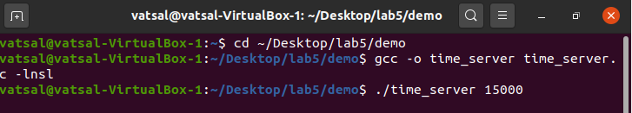

*Figure 5: Server-side commands*

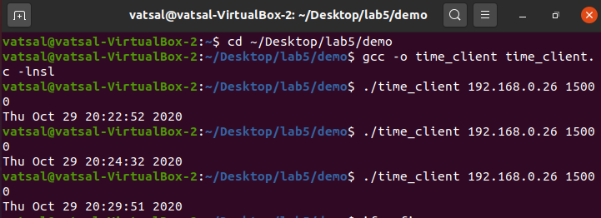

*Figure 6: Client-side commands*

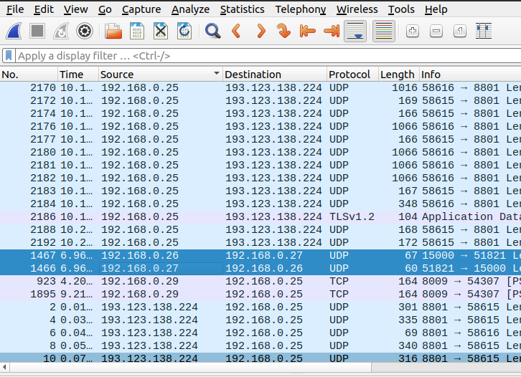

*Figure 7: Wirehshark capture of the 2 UDP packets*

**Conclusion**

The answers to the lab questions are listed below:

1. To demonstrate the completion of steps 1-6 of the lab manual, please refer to figures 5, 6 and 7. These figures show the Server/Client-side commands as well as the Wireshark capture of the 2 UDP packets.

2. The server uses the recvfrom()method to extract the client-side (source) port number from the segment it receives from the client, which is the message; it then sends a new segment to the client, with the extracted source port number serving as the destination port number in this new segment.

3. UDP protocol is more suitable for Time service because it provides fast and efficient transmission. UDP also allows to run multiple clients on one server and it is lightweight. There is no ordering of messages, no tracking connections. No handshaking.

4. Concurrency is more appropriate because concurrent server can serve multiple clients with at the same time (faster connection). Concurrency also allows to run multiple clients in parallel.

5. The programs have been demonstrated for both time\_server as well as time\_client as per figures 1, 2, 3 and 4.

6. The logic used to enable the server to transfer the complete file to the client is listed between lines 74-130, figure 4.

7. The logic used to enable the client to receive the complete file from the server is listed between lines 126-131, figure 2.

8. The client handles the error message through a function strstr(). It is a function that finds the first occurrence of the substring in the string. This is evident from line 103, figure 2.

**References**

1. Coonjah, I., Catherine, P. C., & Soyjaudah, M. S. (2015). Experimental performance comparison between TCP vs UDP tunnel using OpenVPN. Paper presented at the 1-5.
2. Gu, Y., & Grossman, R. L. (2007). UDT: UDP-based data transfer for high-speed wide area networks. Computer Networks (Amsterdam, Netherlands : 1999), 51(7), 1777-1799.